**SQL Assignment: All concepts I**

**Download the following database file from the link:**

**AirlineDB**: https://drive.google.com/file/d/15ehp3FtyuYqExne3FaFcWHB4TFI_vtSR/view?usp=sharing

**Table structure**

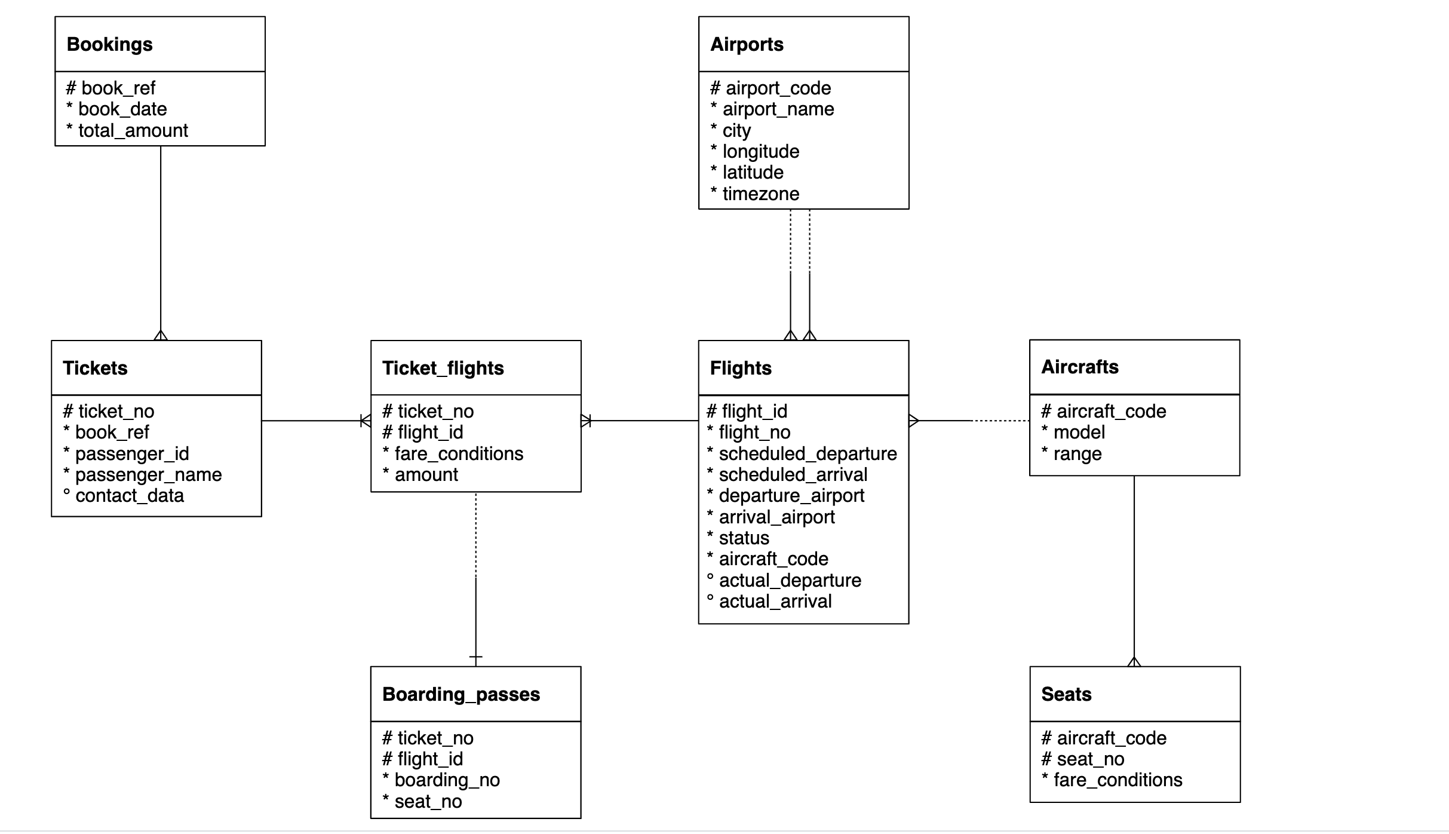

Important Instructions:

* Download the database link and restore in postgres. For restoration, you can refer to the instructions in the first chapter of SQL
* The AirlineDB is quite big in size, hence restoration might take time. Once the restoration starts, wait for 15 to 20 mins and don’t shut down the computer
* Table names in database has “**booking.”** as prefix. For example, bookings.tickets, bookings.boarding_passes. Hence use the prefix in the query as well
  + Correct way of accessing tables: SELECT * FROM **bookings.tickets**
  + Wrong way of accessing tables: SELECT * FROM tickets
* Queries need to be submitted in a **word/text file**. CSV output of the queries will **NOT** be accepted
* Expected output written is written in some of the following question to make sure that you are getting the columns in the same sequence. It doesn’t mean that you will get same values in the output. The exact values in your queries might be different depending on the values sorted in your copy of database.

1. Represent the “book_date” column in “yyyy-mmm-dd”. User Bookings table

ANSWER: SELECT

book_ref,

to_char(book_date,'YYYY-MON-DD')book_date,

total_amount

FROM bookings.bookings

*Expected output*

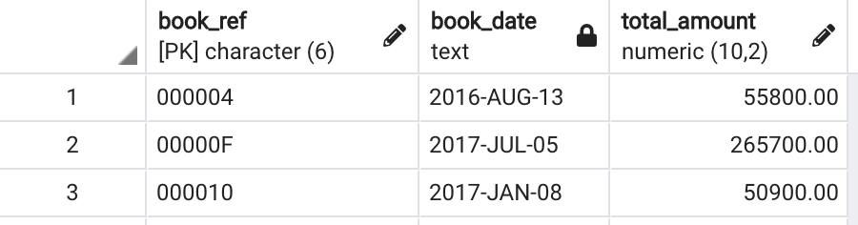

1. Create a table having ticket_no, boarding_no, seat_number, passenger_id, passenger_name.

ANSWER: SELECT

T.ticket_no,

B.boarding_no,

B.seat_no,

T.passenger_id,

T.passenger_name

FROM bookings.Tickets T

JOIN bookings.Boarding_passes B ON T.ticket_no=B.ticket_no

*Expected output*

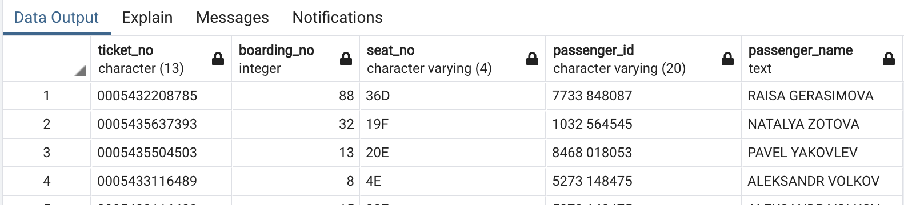

1. Which seat number is least allocated among all the seats?

ANSWER: SELECT

seat_no,

COUNT( seat_no) AS C_seat

FROM bookings.Boarding_passes

GROUP BY seat_no

ORDER BY C_seat ASC

LIMIT 1

1. In the database, identify the month wise highest paying passenger name and passenger id

ANSWER: SELECT

*

FROM(SELECT

RANK() OVER (PARTITION BY month_name ORDER BY total_amount DESC) AS Rank,

month_name,

passenger_id,

passenger_name,

total_amount

FROM

(SELECT

to_char(B.book_date,'Mon-DD') month_name,

T.passenger_id,

T.passenger_name,

B.total_amount

FROM bookings.Bookings B

JOIN bookings.Tickets T

ON B.book_ref=T.book_ref

ORDER BY month_name ASC,B.total_amount DESC) as A_table) as B_table

WHERE Rank=1

*Expected output*

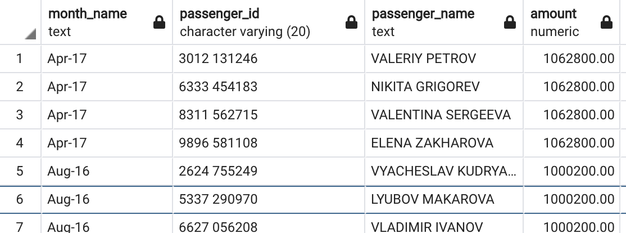

1. In the database, identify the month wise least paying passenger name and passenger id?

ANSWER: SELECT

*

FROM(SELECT

RANK() OVER (PARTITION BY month_name ORDER BY total_amount ASC) AS Rank,

month_name,

passenger_id,

passenger_name,

total_amount

FROM

(SELECT

to_char(B.book_date,'Mon-DD') month_name,

T.passenger_id,

T.passenger_name,

B.total_amount

FROM bookings.Bookings B

JOIN bookings.Tickets T

ON B.book_ref=T.book_ref

ORDER BY month_name ASC,B.total_amount ASC) as A_table) as B_table

WHERE Rank=1

*Expected output*

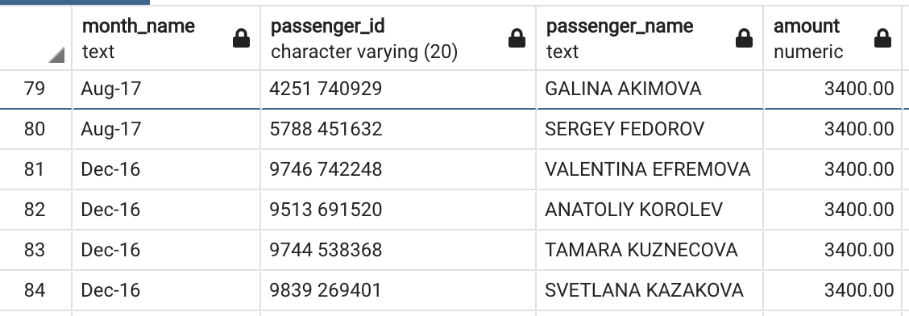

1. Identify the travel details of non no stop journeys or return journeys (having more than 1 flight).

ANSWER: SELECT

T.passenger_id,

T.passenger_name,

F.ticket_no,

COUNT(F.ticket_no) AS flight_count

FROM bookings.Tickets T

JOIN bookings.Ticket_flights F

ON T.ticket_no=F.ticket_no

GROUP BY T.passenger_id,T.passenger_name,F.ticket_no

HAVING COUNT(F.ticket_no) > 1

*Expected output*

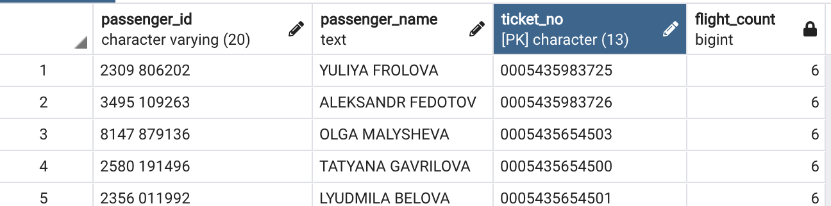

1. How many tickets are there without boarding passes?

ANSWER: SELECT

COUNT(T.ticket_no)

FROM bookings.Tickets T

FULL OUTER JOIN bookings.boarding_passes B

ON T.ticket_no=B.ticket_no

WHERE B.ticket_no is NULL

1. Identify details of the longest flight (using flights table) ?

ANSWER: SELECT

*

FROM(SELECT

RANK() OVER (ORDER BY DIFFERENCE DESC) Rank,

*

FROM(SELECT

*,

EXTRACT(EPOCH FROM(Scheduled_arrival-Scheduled_departure)) AS DIFFERENCE

FROM bookings.flights) TABLEA_B) TABLEC_D

WHERE Rank=1

1. Categorize flights using following logic (using flights table) :
   1. Early morning flights: 2 AM to 6AM
   2. Morning flights: 6 AM to 11 AM
   3. Noon flights: 11 AM to 4 PM
   4. Evening flights: 4 PM to 7 PM
   5. Night flights: 7 PM to 11 PM
   6. Late Night flights: 11 PM to 2 AM

ANSWER: SELECT

*,

CASE

WHEN

CAST(scheduled_departure AS TIME) BETWEEN '02:00:00' AND '06:00:00' THEN 'Early Morning Flight'

WHEN

CAST(scheduled_departure AS TIME) BETWEEN '06:00:00' AND '11:00:00' THEN 'Morning Flight'

WHEN

CAST(scheduled_departure AS TIME) BETWEEN '11:00:00' AND '16:00:00' THEN 'Noon Flight'

WHEN

CAST(scheduled_departure AS TIME) BETWEEN '16:00:00' AND '19:00:00' THEN 'Evening Flight'

WHEN

CAST(scheduled_departure AS TIME) BETWEEN '19:00:00' AND '23:00:00' THEN 'Night Flight'

WHEN

CAST(scheduled_departure AS TIME) BETWEEN '23:00:00' AND '02:00:00' THEN 'Late Night Flight'

END AS Timings

FROM bookings.flights

*Expected output*

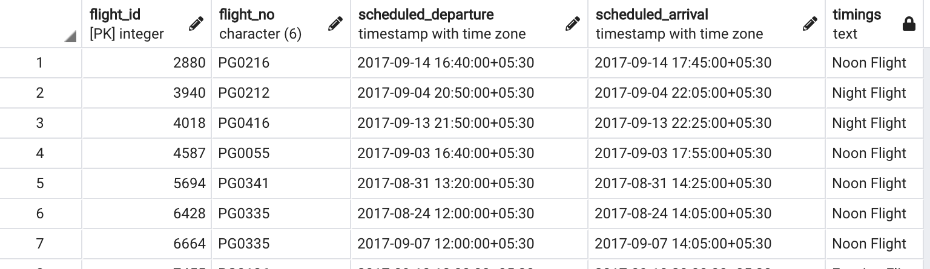

1. Identify details of all the morning flights (morning means between 6AM to 11 AM, using flights table) ?

ANSWER: SELECT

*

FROM(SELECT

*,

CASE

WHEN

CAST(scheduled_departure AS TIME) BETWEEN '02:00:00' AND '06:00:00' THEN 'Early Morning Flight'

WHEN

CAST(scheduled_departure AS TIME) BETWEEN '06:00:00' AND '11:00:00' THEN 'Morning Flight'

WHEN

CAST(scheduled_departure AS TIME) BETWEEN '11:00:00' AND '16:00:00' THEN 'Noon Flight'

WHEN

CAST(scheduled_departure AS TIME) BETWEEN '16:00:00' AND '19:00:00' THEN 'Evening Flight'

WHEN

CAST(scheduled_departure AS TIME) BETWEEN '19:00:00' AND '23:00:00' THEN 'Night Flight'

WHEN

CAST(scheduled_departure AS TIME) BETWEEN '23:00:00' AND '02:00:00' THEN 'Late Night Flight'

END AS Timings

FROM bookings.flights) AS TABLEA_B

WHERE Timings='Morning Flight'

1. Identify the earliest morning flight available from every airport.

ANSWER: SELECT

flight_id,

flight_no,

scheduled_departure,

scheduled_arrival,

departure_airport,

Timings

FROM(SELECT

RANK() OVER (PARTITION BY departure_airport ORDER BY scheduled_departure ASC ) AS Rank,

flight_id,

flight_no,

scheduled_departure,

scheduled_arrival,

departure_airport,

Timings

FROM(SELECT

*,

CAST(scheduled_departure AS TIME) AS HOUR ,

CASE

WHEN

CAST(scheduled_departure AS TIME) BETWEEN '02:00:00' AND '06:00:00' THEN 'Early Morning Flight'

WHEN

CAST(scheduled_departure AS TIME) BETWEEN '06:00:00' AND '11:00:00' THEN 'Morning Flight'

WHEN

CAST(scheduled_departure AS TIME) BETWEEN '11:00:00' AND '16:00:00' THEN 'Noon Flight'

WHEN

CAST(scheduled_departure AS TIME) BETWEEN '16:00:00' AND '19:00:00' THEN 'Evening Flight'

WHEN

CAST(scheduled_departure AS TIME) BETWEEN '19:00:00' AND '23:00:00' THEN 'Night Flight'

WHEN

CAST(scheduled_departure AS TIME) BETWEEN '23:00:00' AND '02:00:00' THEN 'Late Night Flight'

END AS Timings

FROM bookings.flights) AS TABLEA_B

WHERE Timings='Morning Flight' ) AS TABLEC_D

WHERE Rank=1

*Expected output*

